Homework (Local Area Networks)
CS330 Computer Networks

Question 1

1) What is the difference between Ethernet and IEEE 802.3 networks?
……………………………………………………………………………
……………………………………………………………………………
……………………………………………………………………………

Answer the following questions by Yes or No and argue your answer.
2) Is it possible that Ethernet and IEEE 802.3 hosts share the same media?
……………………………………………………………………………
……………………………………………………………………………

3) Does Ethernet retransmit frames?
……………………………………………………………………………
……………………………………………………………………………

4) Does Ethernet acknowledge received frames?
……………………………………………………………………………
……………………………………………………………………………

5) Does Ethernet perform error detection?
……………………………………………………………………………
……………………………………………………………………………

6) Does Ethernet detect duplicated frames?
……………………………………………………………………………
……………………………………………………………………………

Question 2

The following frame was received over an Ethernet/IEEE 802.3 network. The CRC of the frame is not displayed.

Frame
0180 c200 0000 0000 a2e4 91e1 0026 4242
0300 0000 0000 8000 0000 a2e4 91e0 0000
0000 8000 0000 a2e4 91e0 8004 0000 1400
0200 0f00 aaaa aa55 5555 5555

- Why an Ethernet/IEEE 802.3 frame is preceded by a preamble and a Start Frame Delimiter?
……………………………………………………………………………………………………………………………………………
……………………………………………………………………………
……………………………………………………………………………

- The previous frame is represented using hexadecimal digits. What is the binary value of the first received bit of the frame?
……………………………………………………………………………
……………………………………………………………………………

- What is the destination MAC address of the frame and what is its type?
……………………………………………………………………………
……………………………………………………………………………
……………………………………………………………………………

- What is the source MAC address of the frame and what is its type?
……………………………………………………………………………
……………………………………………………………………………
……………………………………………………………………………

- What is the type of the received frame (Ethernet or IEEE 802.3)?
……………………………………………………………………………
……………………………………………………………………………

- An Ethernet/IEEE 802.3 frame should have a minimal size of 64 bytes; otherwise padding bytes are added to the Data field. Why an Ethernet/IEEE 802.3 should have a minimal size?
……………………………………………………………………………
……………………………………………………………………………
- Are there any padding bytes in this frame? If your response is yes, how many padding bytes are present in the frame?
……………………………………………………………………………
……………………………………………………………………………

- What is the next protocol that will process the data field of the frame?
……………………………………………………………………………
……………………………………………………………………………
……………………………………………………………………………

- What is the highest level protocol transported by this frame?
……………………………………………………………………………
……………………………………………………………………………
……………………………………………………………………………

- What is the purpose of this protocol (highest level protocol)?
……………………………………………………………………………
……………………………………………………………………………
……………………………………………………………………………

- What is the type of the equipment that had sent this frame?
……………………………………………………………………………
……………………………………………………………………………

- What are the potential receivers of this frame?
……………………………………………………………………………
……………………………………………………………………………

Question 3
The figure below is for LANs connected with bridges, and suppose that the Bridging tables are empty.

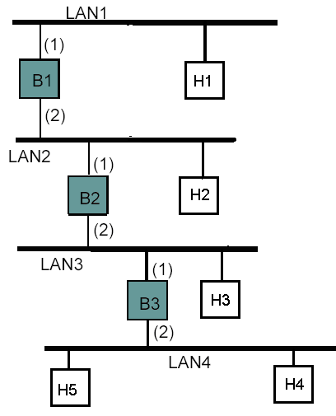
1) After H4 sends a frame to H5, give the new contents of the different bridging tables?
…………………………………………………………………………………………………………………………………………………………
……………………………………………………………………………………………………………………………………………………………………………………………………………………………………………………………………………………………………………………
2) After that H5 sends a frame to H4, give the new contents of the different bridging tables?
……………………………………………………………………………………………………………………………………………………………………………………………………………………………………………………………………………………………………………………
……………………………………………………………………………
3) What happens in case of the failure of B2 and what is the proposed solution to have a fault-tolerant topology?
………………………………………………………………………………………………………………………………………………………………………………………………………………………………………

