Classroom: 1101  FreeBSD (Press F2)  username: root  password: net-lab |  | Computer Networks (CS330)  Lab
 |  | Dr. Miled Tezeghdanti
.........................................................................................الاسم:

.........................................................................................الاسم:

.........................................................................................الاسم:

Ethernet and Static Routing

Useful Commands
Before using a command, try to consult its manual (man command_name, for example: man ifconfig). Main commands that you need in this lab are:
- ifconfig allows the modification and the display of a network interface configuration.
- ping checks the operation of the IP protocol.
- tcpdump captures and analyses the traffic over the network.
- netstat allows the display of the routing table.
- route allows routing table management.
- arp displays the content of the ARP table.
- traceroute displays the list of routers on the path from source to destination.
The lab contains 16 PCs (HP Compaq with HP 1702 flat monitor). Each PC has 2 Ethernet interfaces: a motherboard build-in Ethernet interface which appears as the interface fxp0 and a PCI Ethernet interface which appears as the interface xl0 (rl0 or vr0 for some PCs). The lab contains 4 Cisco Catalyst 2950 (WS-C2950T-24) switches (S2 to S5). Each switch has 24 Fast Ethernet ports numbered from Fast Ethernet 0/1 to Fast Ethernet 0/24 and 2 Giga Ethernet ports: Giga Ethernet 0/1 and Giga Ethernet 0/2. Each switch has a console port which can be used for out-of-band management. The console port should be connected to the serial interface of a PC using the light blue console cable (RJ45-DB9). Under FreeBSD, the command tip with appropriate parameters in the /etc/remote file is used to configure the switch. The lab contains also 4 Cisco 1841 routers (R1 to R4). Each router has 2 Fast Ethernet: Fast Ethernet 0/0 and Fast Ethernet 0/1, 2 serial ports: Serial 0/0 and Serial 0/1, and a console port used for out-of-band management of the router.
The lab is connected to the College network via a Cisco Catalyst 2950 WS-C2950SX-48-SI switch (S1). This switch has 48 Fast Ethernet ports numbered from Fast Ethernet 0/1 to Fast Ethernet 0/24 and 2 Giga Ethernet (1000BaseSX) ports: Giga Ethernet 0/1 and Giga Ethernet 0/2. The configuration of this switch must not be modified during all labs.
To connect to switches, you can use Ethernet sockets under your office. These sockets are numbered from 1 to 29 and are connected to the switch rack via cables numbered from 1 to 29. Cables in the rack should be connected to switches’ ports as requested for each lab. To connect to switches straight Cat 5 UTP cables are used (black cables). To connect directly between PCs or routers, cross-over Cat 5 UTP cables are used (white cables).
The following figure shows different lab equipments and the number of each PC.

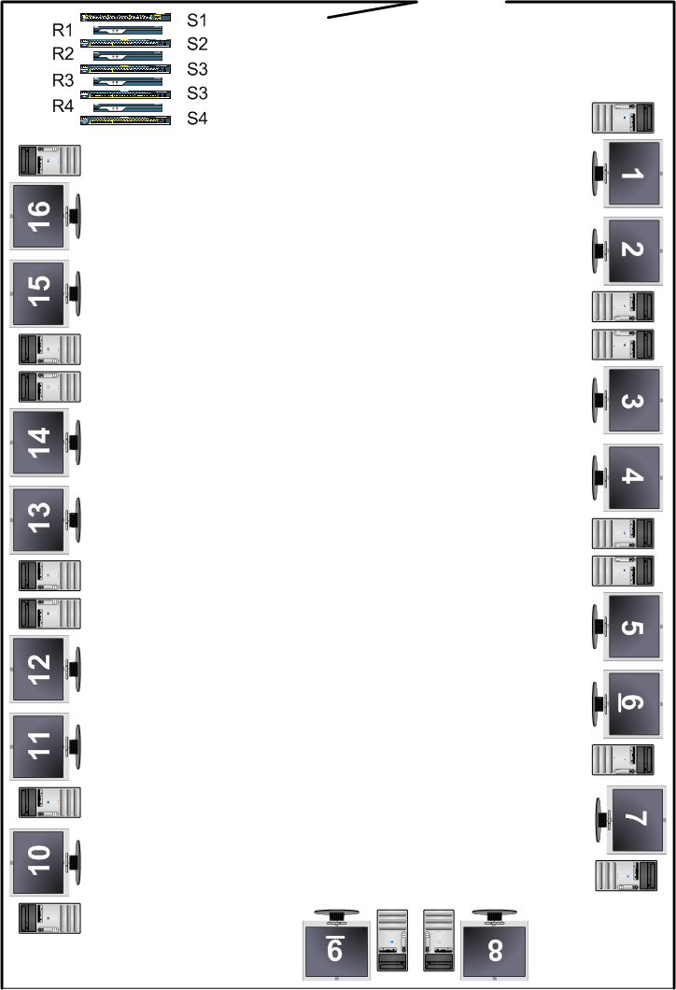
Figure 1: Network Lab
In the previous figure, each host (PC) is identified by a number. Each host has two Ethernet interfaces fxp0 and xl0 (rl0 or vr0 for some stations). We will use an addressing scheme based on the following prefixes:
192.168.X.0/24 where:
X: is the number of the host if this number is an odd number.
X: is the number of the host – 1 if this number is an even number.
The address 192.168.X.1 is allocated to the Ethernet interface fxp0 (bfe0 for the Dell PC) of the odd host and the address 192.168.X.2 is allocated to the Ethernet interface fxp0 (bfe0 for the Dell PC) of the even host. In fact, hosts X and X+1 (X is an odd number) belong to the same IP network which has the prefix 192.168.X.0/24.
Using the cross-over cable (white cable), connect your host to your neighbor host.

Question 1
What is the IP address allocated to your host?
…………………………………………………………………………………………………...

Question 2
What is the domain of this address (private or public domain)?
…………………………………………………………………………………………………...

Question 3
What is the correspondent netmask of this address?
…………………………………………………………………………………………………...

Question 4
What is the MAC address of the Ethernet interface fxp0 (bfe0 for the Dell PC)?
…………………………………………………………………………………………………...
At first time, we will try to reach from our host the host connected to the same IP network. For that purpose, we will open a terminal where we will use the ping command.

Question 5
What is the message obtained by the ping command?
…………………………………………………………………………………………………...
Actually, you need to configure the Ethernet interface of your host with the ifconfig command. Before executing the ifconfig command, start the tcpdump command to parse the traffic circulating over the network.
To start the tcpdump command, you need to change the interface to the up state. This can be done with the command:
ifconfig fxp0 up
On the Dell PC, the above command should be: ifconfig bfe0 up
(you can see the different available Ethernet interfaces by typing the ifconfig command without parameters )
To execute tcpdump, open a new terminal and use the following command:
tcpdump –i fxp0 –exns 0
On the Dell PC, the above command should be: tcpdump –i bfe0 –exns 0

This command displays all the traffic seen by the interface fxp0 (bfe0 for the Dell PC). The Ethernet header and all the content of the packet is displayed in hexadecimal (see the command manual for more details).
You should always have 2 running terminals:
- One is dedicated to tcpdump
- The other is dedicated to other commands: ifconfig, ping, netstat, route, arp, and traceroute

Question 6
After the execution of the ifconfig command, what is the type of the message that it is sent over the network?
If you don't see any message, repeat the last ifconfig command again after the execution of tcpdump.
…………………………………………………………………………………………………...
Explain?
…………………………………………………………………………………………………...
…………………………………………………………………………………………………...
…………………………………………………………………………………………………...

Question 7
What is the value of the Type field of the Ethernet frame?
…………………………………………………………………………………………………...

Question 8
What is the Destination Address of the frame?
…………………………………………………………………………………………………...

Question 9
Why the Destination Address has this value?
…………………………………………………………………………………………………...

Again, try to ping the host connected to the same network.

Question 10
Is it sufficient to configure the Ethernet interface of your host?
…………………………………………………………………………………………………...

Question 11
What are the types of the messages traveling over the network?
…………………………………………………………………………………………………...
…………………………………………………………………………………………………...
…………………………………………………………………………………………………...

Now try to ping the address 192.168.X.3.

Question 12
What is the obtained message?
…………………………………………………………………………………………………...
Explain?
…………………………………………………………………………………………………...
…………………………………………………………………………………………………...
…………………………………………………………………………………………………...

Now, we will try to ping a host that is connected to another network.

Question 13
What is the message obtained by the ping command?
…………………………………………………………………………………………………...
Explain?
…………………………………………………………………………………………………...
…………………………………………………………………………………………………...
…………………………………………………………………………………………………...
In fact, the different networks are not connected together. In this step, we will use an interconnection network to connect between different networks.
The interconnection network has the prefix 192.168.100.0/24. Each host will be connected to this network via the Ethernet interface xl0 (rl0 or vr0 for some hosts) using straight cable (black cable). Each PC will be considered as a router and will have as a second address 192.168.100.Y where Y is the number of the host. Use the ifconfig to implement this addressing scheme.

Now, again we will try to ping a host that is connected to another network.

Question 14
What is the message obtained by the ping command?
…………………………………………………………………………………………………...

In fact, we need to configure the routing table using the command route in order to reach the other networks.
On each PC router, add a route to each other network in the lab (192.168.X.0/24, except for his own network and the interconnection network).
Now, again we will try to ping a host that is connected to another network.

Question 15
What is the message obtained by the ping command?
…………………………………………………………………………………………………...

Question 16
Draw the logic topology (at the IP level) of the system containing all IP networks in the lab.

Now, we will configure routing tables. For that purpose, we will use default routing.
The router 192.168.100.1 adds a default route to the router 192.168.100.3 and vice versa.
The router 192.168.100.2 adds a default route to the router 192.168.100.4 and vice versa.
The router 192.168.100.5 adds a default route to the router 192.168.100.7 and vice versa.
The router 192.168.100.6 adds a default route to the router 192.168.100.8 and vice versa.
The router 192.168.100.9 adds a default route to the router 192.168.100.11 and vice versa.
The router 192.168.100.10 adds a default route to the router 192.168.100.12 and vice versa.
The router 192.168.100.13 adds a default route to the router 192.168.100.15 and vice versa.
The router 192.168.100.14 adds a default route to the router 192.168.100.16 and vice versa.

From your PC router, try to ping a host that is located over a network that is different from your network or the network of your default router.

Question 17
What is the generated ICMP message?
…………………………………………………………………………………………………...
Explain?
…………………………………………………………………………………………………...
…………………………………………………………………………………………………...
…………………………………………………………………………………………………...

To avoid loop construction, we will use the following default routing scheme:
The router 192.168.100.Y adds a default route to the router 192.168.100.Y+1.
The router 192.168.100.Ymax adds a default route to the router 192.168.100.1.

Again, try to ping the same previous host.

Use the traceroute command to display the path followed by packets.

Question 18
What is the protocol used by the traceroute command?
…………………………………………………………………………………………………...
Explain the operation of this command?
…………………………………………………………………………………………………...
…………………………………………………………………………………………………...
…………………………………………………………………………………………………...
Add a route for each existent network.

Question 19
What are the shortcomings of static routing?
…………………………………………………………………………………………………...
…………………………………………………………………………………………………...
…………………………………………………………………………………………………...
…………………………………………………………………………………………………...
Examples of commands

ifconfig fxp0
displays the Ethernet address of the interface fxp0

ifconfig fxp0 192.168.20.1 netmask 255.255.255.0
assigns the IP address to the Ethernet interface fxp0

tcpdump –i fxp0 –enxs 0
displays the traffic traveling on the network connected to the interface fxp0

tcpdump –i fxp0 arp
displays the ARP traffic traveling on the network connected to the interface fxp0

tcpdump –i fxp0 ip
displays the IP traffic traveling on the network connected to the interface fxp0

tcpdump –i fxp0 icmp
displays the ICMP traffic traveling on the network connected to the interface fxp0

tcpdump –i fxp0 ospf
displays the OSPF traffic traveling on the network connected to the interface fxp0

tcpdump –i fxp0 tcp
displays the TCP traffic traveling on the network connected to the interface fxp0

tcpdump –i fxp0 udp
displays the UDP traffic traveling on the network connected to the interface fxp0

ping 192.168.20.2
pings the hots with the IP address 192.168.20.2

netstat –rn
displays the routing table

arp –a
displays the ARP table

route add default 192.168.20.2
adds a default route via the router 192.168.20.2

route delete default
deletes the default route

route add 192.168.30.0/24 192.168.20.3
adds a route to the network 192.168.30.0/24 via the gateway 192.168.20.3

traceroute 192.168.20.2
traces the route towards the host with the IP address 192.168.20.2

